Khushika Shah

ENGL 393, Section 6

Rhetorical Analysis

October 27, 2024

**Rhetorical Analysis: A Bark for Care**

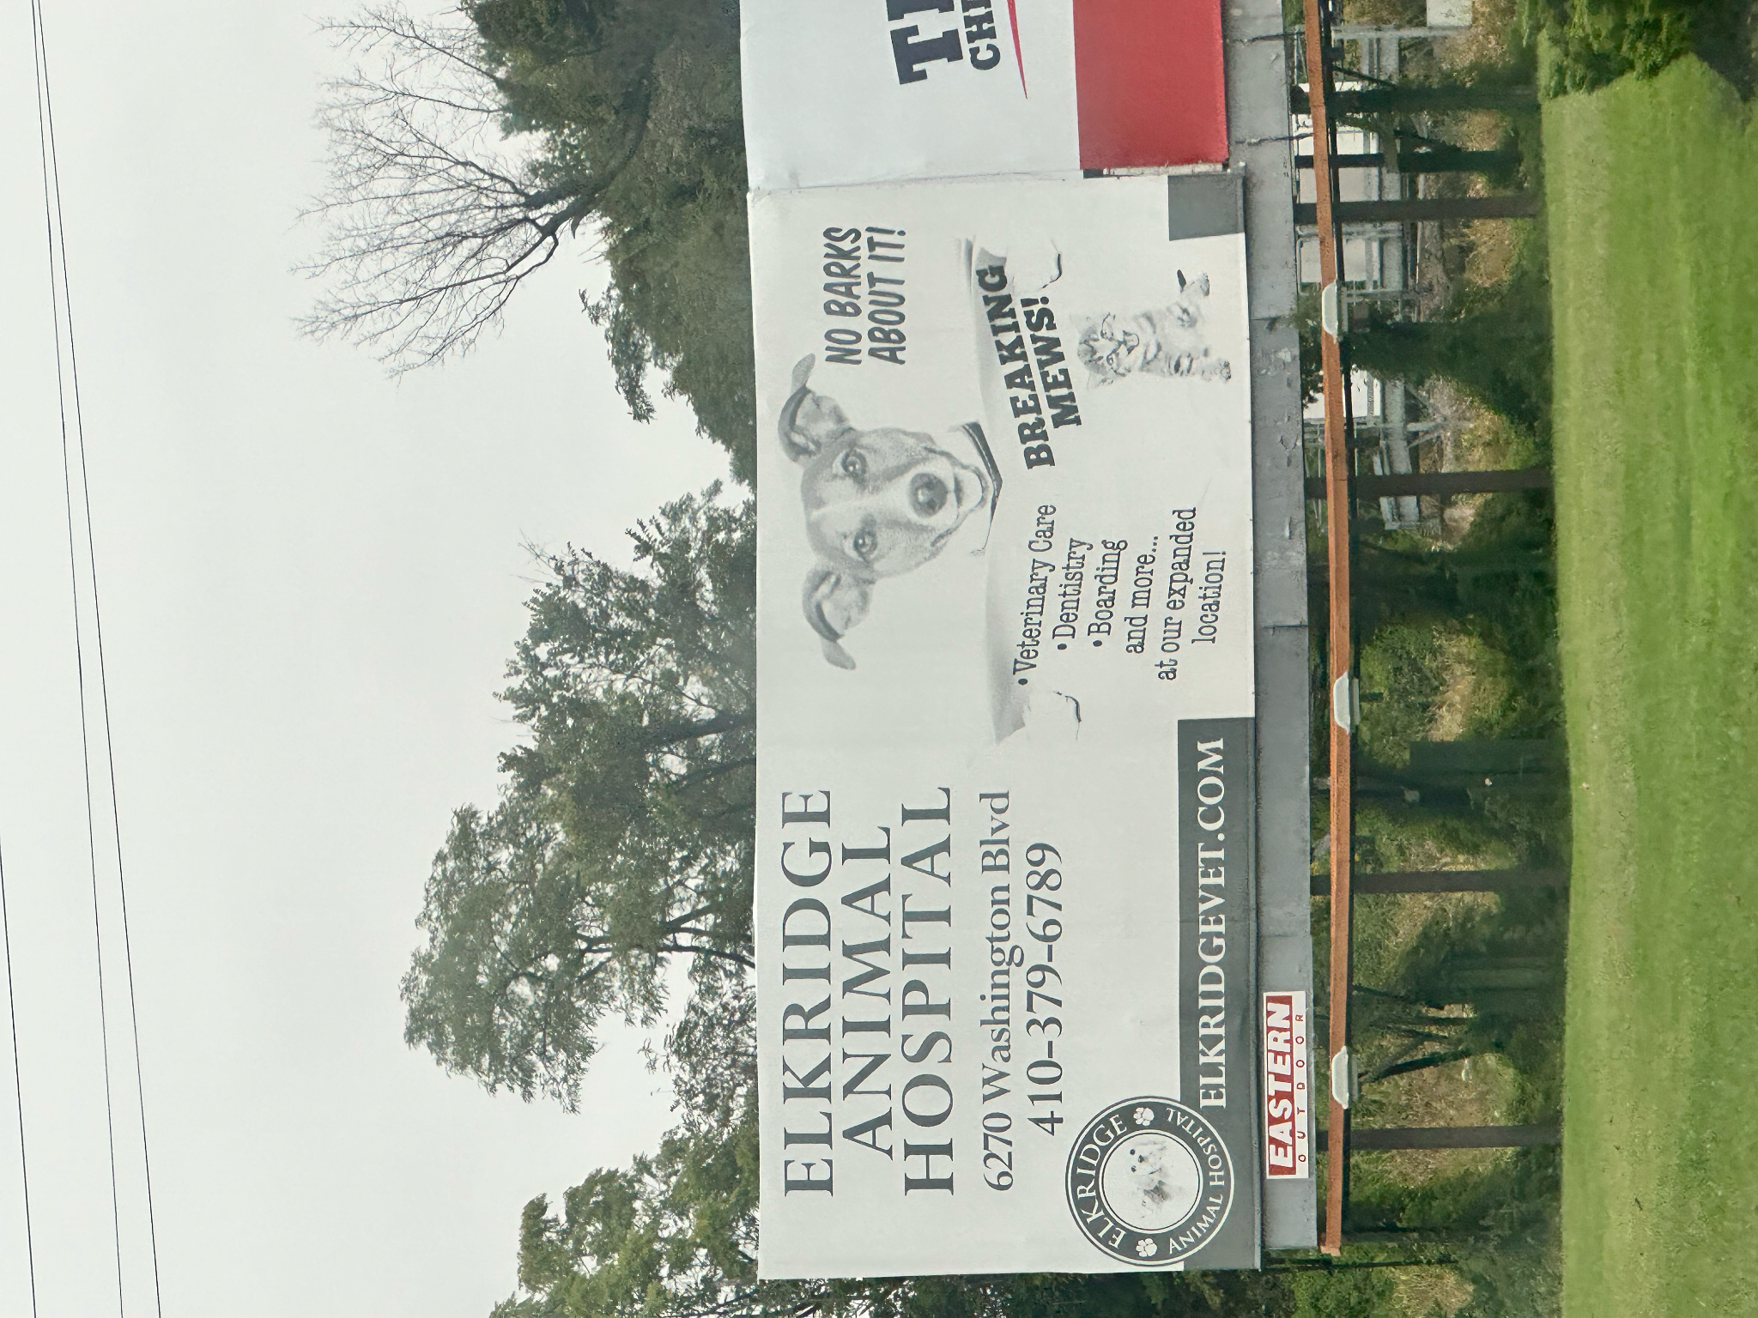

Advertising through billboards conveys messages to the public in an accessible and creative way. The Elkridge Animal Hospital billboard, located in Arbutus, MD, uses this medium by using playful language and inviting imagery to capture the attention of pet owners. With phrases like "No Barks About It" from a cheerful dog and "Breaking Mews" from a kitten, the billboard delivers a lighthearted yet persuasive message about the hospital’s services. Through a clever combination of humor, visual appeal, and credible information, this billboard shows how the hospital is driving interest in the services they offer.

The billboard is positioned low to the ground and is large in size, allowing it to be seen from a distance. There are playful puns on the billboard, such as a dog saying “No Barks About It!” and reading a newspaper that has a cat on the front page saying “Breaking Mews." It is white in background with black text showing a black and white contrast on the billboard. The billboard has different font types and designs to bring attention to the main text. The hospital’s name, “Elkridge Animal Hospital,” is in bold with the largest font size. The puns “said” by the dog and cat are bolded and slightly italicized to emphasize and draw the viewers’ attention. They are also followed by exclamation marks, putting emphasis on these dialogues. Then there are images of a playful and friendly dog and a kitten so that not only pet owners but passengers in general are prompted to look at the text following the images. Below, in smaller text, the hospital gives its address and contact information and what type of veterinary services they offer on the last page of the newspaper.

The primary purpose of this billboard appears to be to attract business by promoting the Elkridge Animal Hospital, but it also serves a deeper function: to remind pet owners and the local community about the importance of veterinary care for their animals. The billboard not only aims to bring attention to the hospital’s services, but also subtly urges pet owners to take action by addressing their pets’ healthcare needs.The phrase “No Barks About It” conveys the message that choosing veterinary care at Elkridge Animal Hospital will leave pet owners completely satisfied, with no complaints or concerns about the quality of service provided. The “Breaking Mews” pun on the other side serves as an eye-catching phrase for onlookers to pause and look at the rest of the billboard.

The audience in this case are pet owners looking for veterinary services like dentistry, boarding, and more for their pets. This billboard is located on the Southwestern Boulevard Road, which is six minutes away from the Elkridge Animal Hospital, giving it the perfect radius for local pet owners to visit the center. The billboard is also prompting pet owners to take better care of their pets by visiting the hospital. A secondary audience can be people in general who want to be pet owners since the billboard shows friendly pets that would persuade people to become pet owners and choose a vet center for their pets.

The billboard appears to appeal to people in the local area in numerous ways. By making it seem like the dog and cats are talking, they are emotionally appealing to pet owners, signifying that animals need care and checkups too. The dialogues “Breaking Mews” and the dog reading a newspaper humanize the animals and invoke sympathy from the audience for the animals (pathos). The billboard’s presence in a residential area suggests that the hospital recognizes the moment to reach pet owners who may need their services regularly. It taps into the idea that people living in family-oriented neighborhoods are more likely to have pets, making the location and message timely and relevant (kairos). The billboard also has its address and contact information and a url to its website on the bottom left corner. It also mentioned some of the services it offers and the fact that the hospital has expanded, giving it reliability and evidence of growth. These elements give credibility to the hospital and appeal to the audience practically (ethos).

There are two distinct tones on the billboard. The left side of the billboard has the information the passengers nearby need to reach out to the hospital, giving it an informative and narrative tone while juxtaposed to the right side, which has visual images and switches to a lighthearted and welcoming tone. This tone of the board removes the formality of the overall context, making it more accessible and attractive to onlookers. It brings humor with puns like “Breaking Mews." It is evident that this lighthearted tone is present more heavily on the board than the informative tone of the billboard. The location of this billboard also plays a significant role in shaping its tone. It is near a residential area, so the advertisement is designed to be kid-friendly and inoffensive to the local community. This choice ensures the message remains approachable and lighthearted, while avoiding any content that could be upsetting or overly serious for passersby. This decision to opt into a playful tone rather than a serious or intense tone about caring for animals intertwines with the author’s decision to choose more of an emotional appeal rather than a logical appeal.

The billboard relies heavily on style and design to convey its message across to onlookers and its target audience. The billboard uses visual images of friendly animals not only on most parts of the board, but also on their logo, which also has a dog and a cat with paws encircling the logo on the bottom left corner. This shows the choice to emotionally appeal to the target audience. The billboard is in black and white and shows no presence of stylistic colors, which could have highlighted the billboard’s appeal and made it more memorable. Emphasizing key text in bold and using colors could have drawn more immediate attention to the hospital’s services. Using black and white could reflect the hospital’s constraints in budgets to promote its services, and so instead of choosing color, the author relies on visual images to bring the appeal. With the information of services and contact information about the hospital, the author could have also chosen to include hours of operations. The hospital also offers a coupon for a free first visit on its website. This information presented on the billboard stylistically could have also given a better incentive for pet owners to reach out to the hospital.

In conclusion, the Elkridge Animal Hospital billboard effectively combines visual elements, humor, and intentional messaging to connect with its target audience of local pet owners. However, incorporating more vibrant colors and key practical details could have further enhanced its appeal and given stronger incentives for clients to engage with the hospital. Regardless, by using other rhetorical strategies such as emotional appeal through playful language and visual imagery, credibility through the information of services and contact details, and a well-chosen location, the billboard attracts attention from pet owners.